International Training Course on Aviation and Satellite Meteorology has started in Ankara

“International Training Course on Aviation and Satellite Meteorology” which was jointly organized by The Turkish Cooperation and Coordination Agency (TIKA) and The Singapore Cooperation Programme (SCP) has started in Regional Training Centre of Turkish State Meteorological Service (TSMS) on 05 February 2018.

Dear Excellency, Ambassador of Singapore, Mr. A. Selverajah, Dr. Mehmet Yılmaz, Head of External Relations and Cooperations of TİKA and Director General of TSMS opened the course with their valuable speeches.

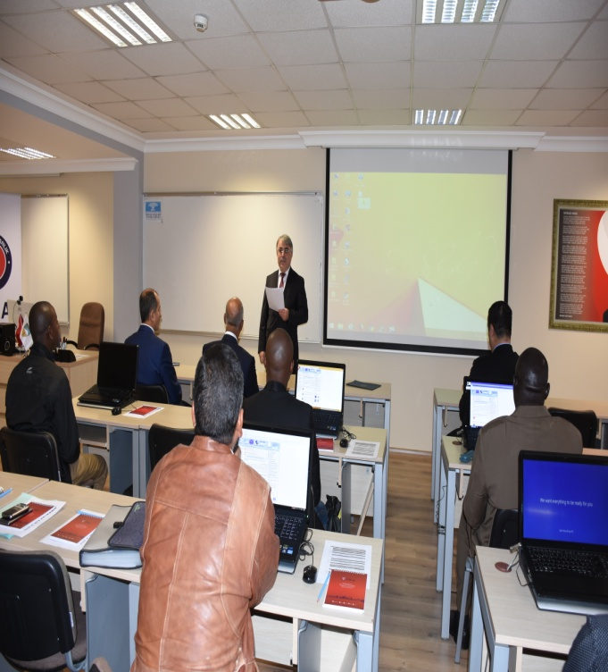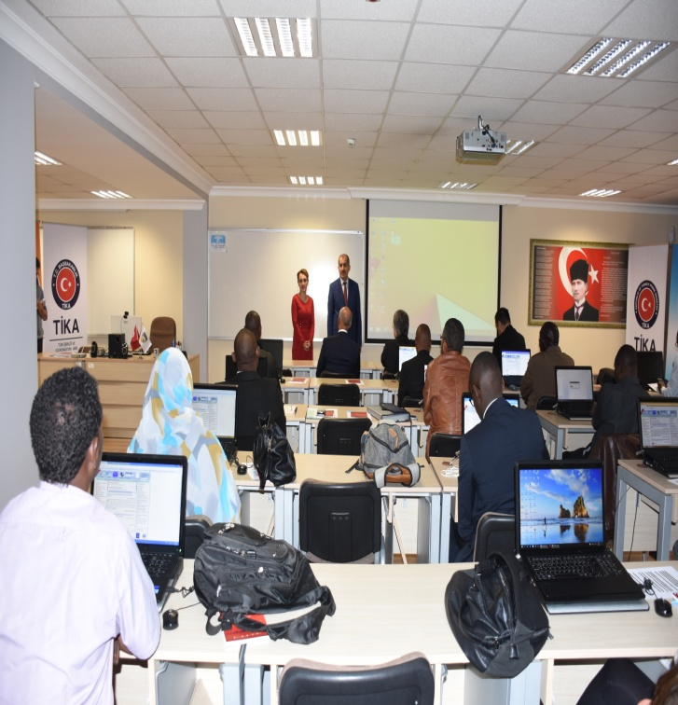

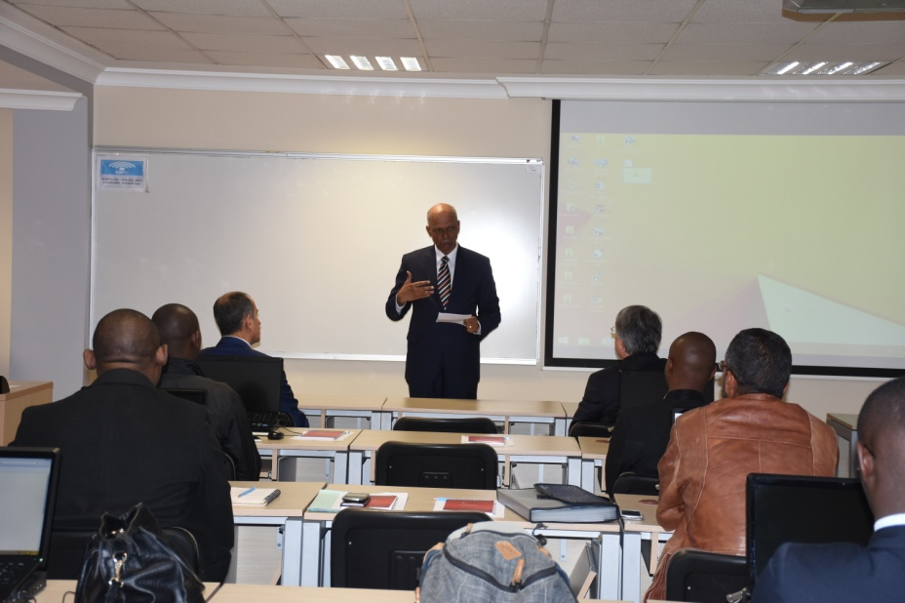

On 05 February 2018, TIKA held a welcome dinner for the participants of this course with the participation of Dear Excellency, Ambassador of Singapore, Mr. A. Selverajah, Dr. Mehmet Yılmaz, Head of External Relations and Cooperations of TİKA and Director General of TSMS. Participants enjoyed their meal.

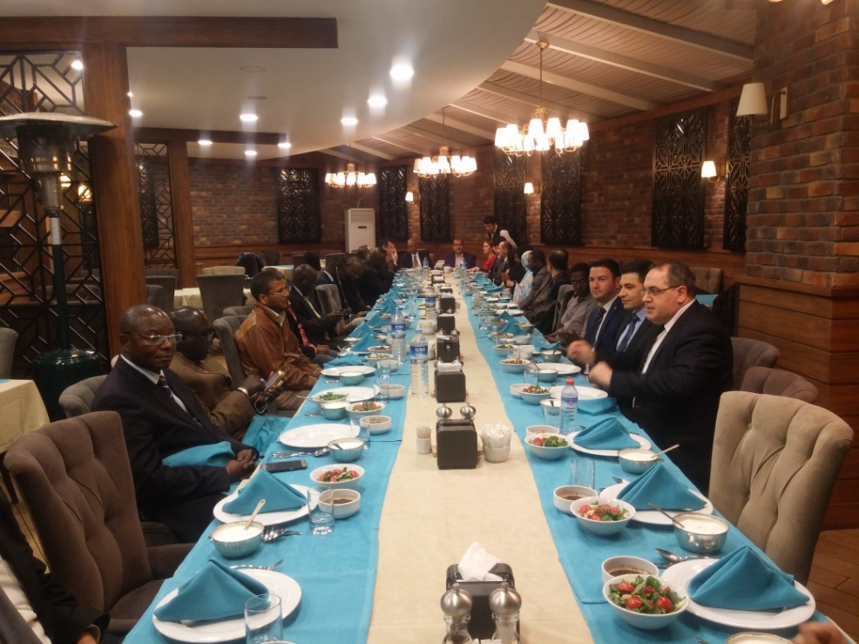

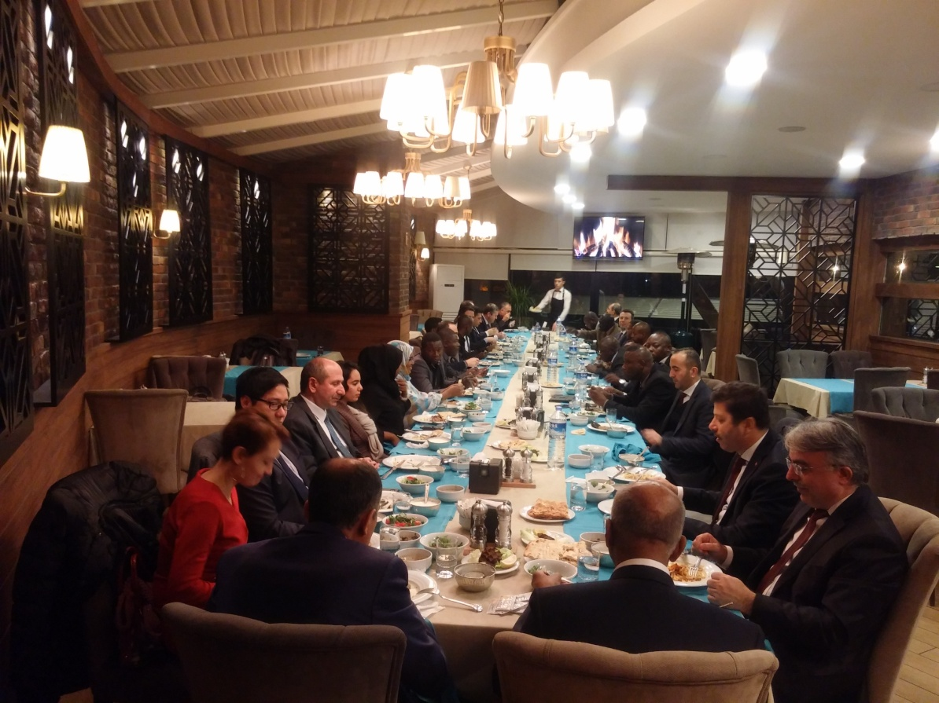

15 meteorologists from Benin, Djibouti, Ethiopia, Morocco, Gambia, Ghana, Guinea, Guinea Bissau, Kenya, Comoros, Congo, Libya, Mauritania, Central African Republic, and Senegal attended this course.

During this course, experts from TSMS and Meteorological Service Singapore (MSS) will give a general overview on aviation and satellite meteorology while also sharing the best practices, experiences and knowledge of the participants. Participants are encouraged to share and discuss their challenges in relation to these issues. The course will finish on 09 February 2018 with a closing ceremony.

